HOW TO USE BLOG CONTENT: Always include your library’s web page with information on how to access ChiltonLibrary or the access page itself. Shorten links with bit.ly, if needed.

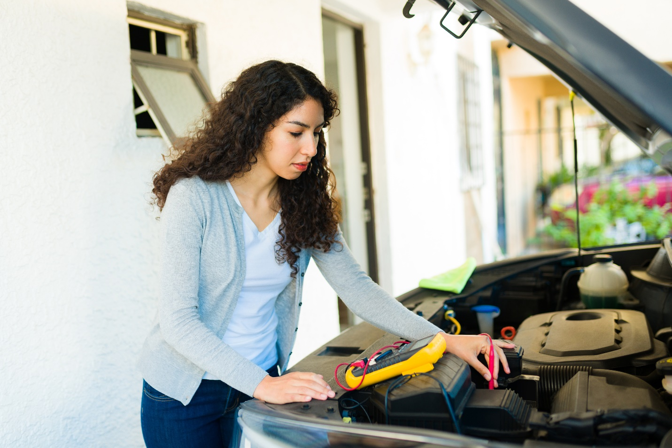

[Headline] April Is National Car Care Month: [INSERT YOUR LIBRARY] Can Help

Accomplish your car care tasks with ChiltonLibrary. It’s available online with tens of thousands of year, make, and model vehicles on tap. Access it remotely from your desktop, laptop, tablet, or phone through [INSERT YOUR LIBRARY].
Need to change your oil? You can look up specifications and procedures in ChiltonLibrary. Remote access on your device lets you bring ChiltonLibrary to your car and auto parts store.
Tackling a bigger job like engine or transmission repair? Original equipment manufacturer (OEM) service manual information has your back with illustrated diagnosis, inspection, and replacement procedures.
Planning to upgrade your speakers? Refer to the ChiltonLibrary factory wiring diagrams and procedures to bring music to your ears.
For those who prefer to listen, the ChiltonLibrary full complement of accessibility tools includes the ability to have repair information read aloud through your device’s speakers.
Prefer a different language? Use the language translation feature to read in your selected language, or choose to have the page read to you. It’s available in more than 20 languages.
Text too small? Use accessibility tools to enlarge fonts, change the color, and other options.
Want to print or save a wiring diagram, text, or other item? It’s easy with ChiltonLibrary.
ChiltonLibrary provides access to OEM repair, maintenance, and service information for popular cars, trucks, vans, and SUVs. Its clean interface and intuitive navigation make finding mechanical repair information easy. In addition, the automotive knowledge base contains:

• Body and collision information with comprehensive specifications and instructions
• Recalls and service bulletins
• Vehicle identification number (VIN) real-time lookup through the National Highway Traffic Safety Administration (NHTSA) to discover original equipment and unrepaired safety recalls
• Labor times to help estimate repair costs
• Preparation for ASE mechanic certification with test prep quizzes

Whether it’s learning the automaker recommendations for keeping your wheels shining or something more detailed, ChiltonLibrary is free through [INSERT YOUR LIBRARY] and there when you need it. Access from any device online at [INSERT YOUR LIBRARY’S ACCESS URL].

